# HTML and CSS

## EXERCISE 2: BASIC CSS

Use the tutorials and references at <http://ww.w3schools.com/css> to create a separate external stylesheet file called ***first-styles.css*** and link it to both your pages. Use **NotePad++**to edit the stylesheet and try and make the first page look like this:

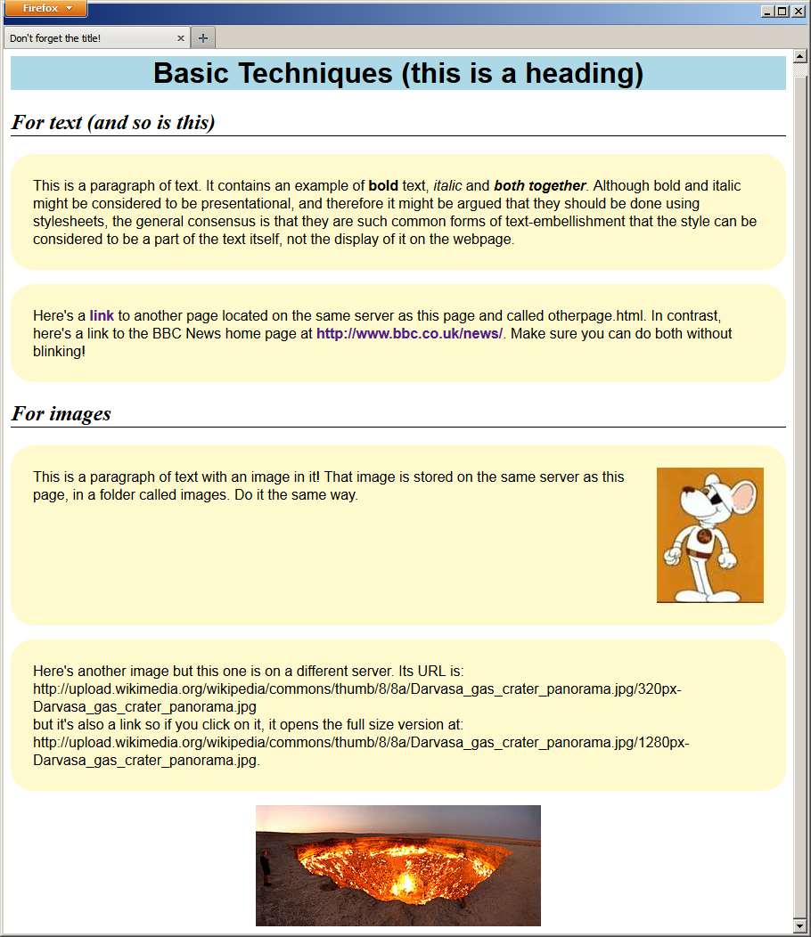

**YOU SHOULD NOT EDIT EITHER OF YOUR HTML PAGES AT ALL APART FROM ADDING THE *LINK* TAG TO ATTACH THE STYLESHEET.**

Review <http://www.w3schools.com/css/css_howto.asp> to make sure you are completely clear about the three different ways in which CSS rules can be added to web pages, how they interact with each other and why you would choose to use each of them.

|  |
| --- |
| **EXERCISE 2: BASIC CSS** |
| ***Required in your report (basic exercise).*** |
| * The contents of the CSS file you used to achieve these results * An explanation of each rule in the CSS file and what it does * A clickable link to the completed web page in your Daydream account (this may be the same page as for the previous task). * A description of the differences between external, internal and inline CSS rules and why they would be used. * Reflection on the tasks and all activities involved. |
| ***Extended Tasks*** |
| * Add styles to the list on the second page. * If you have an HTML table on the second page, add styles to that, including alternate colours to each row. * Experiment with overriding styles defined in the external stylesheet with styles defined in the <head> section of the page and overriding those with styles defined inline. |
| *Additional work: investigate and experiment with any related subject matter that interests you.* |